**GOVERNMENT OF TAMILNADU**

**Naan Mudhalvan – Project Based Experiential Learning**

Project Report on

**HOUSING PRICES IN METROPOLITAN AREARS OF INDIA**

**Submitted by**

**NAME 1 (973D5E4E0EE3A2B888644AE052F6981F)**

**NAME 2 (401A1AE42OF7B8DB94E4E8786F64E6AF)**

**NAME 3 (786DE202D98094284024BC18ACC478D1)**

**NAME 4 (5FA230D7B9B465F9CCA451D02B7D24B2)**

**(TEAM ID : )**

**Under the guidance of**

**Dr. M. GAYATHRI M.Sc., Ph.D**

**Guest Lecturer**

**Department of Mathematics**

GOVERNMENT ARTS COLLEGE FOR WOMEN,

(Affiliated to Mother Teresa Women’s University, Kodaikanal)

Reaccredited with “C” Grade by NAAC

NILAKOTTAI-624 208

1 INTRODUCTION

1.1 Overview

House price prediction in a metropolitan city in India is a valuable solution for potential home buyers, real estate agents, and investors. By leveraging historical sales data, property details, and location-specific information, a predictive model can accurately estimate house prices. The model's scalability, real-time updates, user-friendly interface, and transparency ensure it meets the needs of stakeholders. Integration capability, data privacy, and cost effectiveness are also important considerations. By addressing these requirements, the prediction model provides reliable insights, empowering stakeholders to make informed decisions in the fast-paced real estate market. Analysing Housing Prices in Metropolitan Areas of India House price prediction in a metropolitan city in India is a valuable solution for potential home buyers, real estate agents, and investors. By leveraging historical sales data, property details, and location-specific information, a predictive model can accurately estimate house prices. The model's scalability, real-time updates, user-friendly interface, and transparency ensure it meets the needs of stakeholders. Integration capability, data privacy, and cost effectiveness are also important considerations. By addressing these requirements, the prediction model provides reliable insights, empowering stakeholders to make informed decisions in the fast-paced real estate market.

1.2 Purpose

The business problem at hand is the prediction of house prices in a metropolitan city in India. The real estate market in such cities is complex and dynamic, making it challenging for potential home buyers, real estate agents, and investors to accurately estimate property values. By developing a predictive model using relevant datasets and features, stakeholders can gain insights into the factors influencing house prices and make informed decisions regarding property investments. The goal is to provide a reliable and accurate prediction. Analysing housing prices in  metropoliten areas of India and creating dashboard, story using tableau tool that assists users in navigating the competitive real estate market and maximizing their returns.

2 Problem Definition & Design Thinking

Analysing housing prices in metropoliten areas of India and creating dashboard, story using tablea.

2.1 Empathy Map  
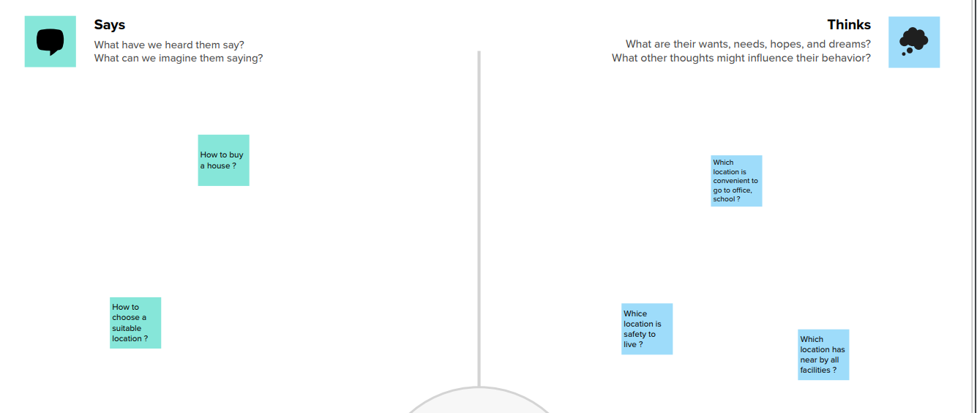

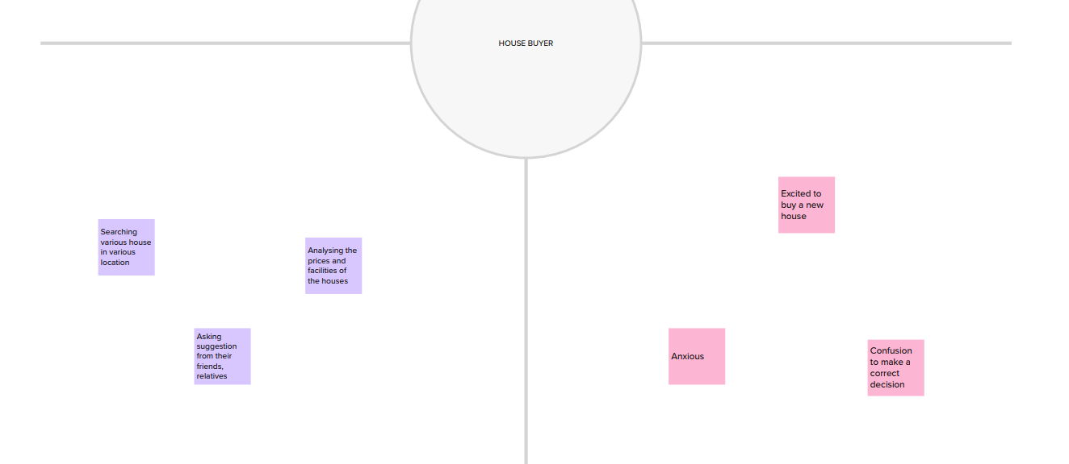  
2.2 Ideation & Brainstorming Map  
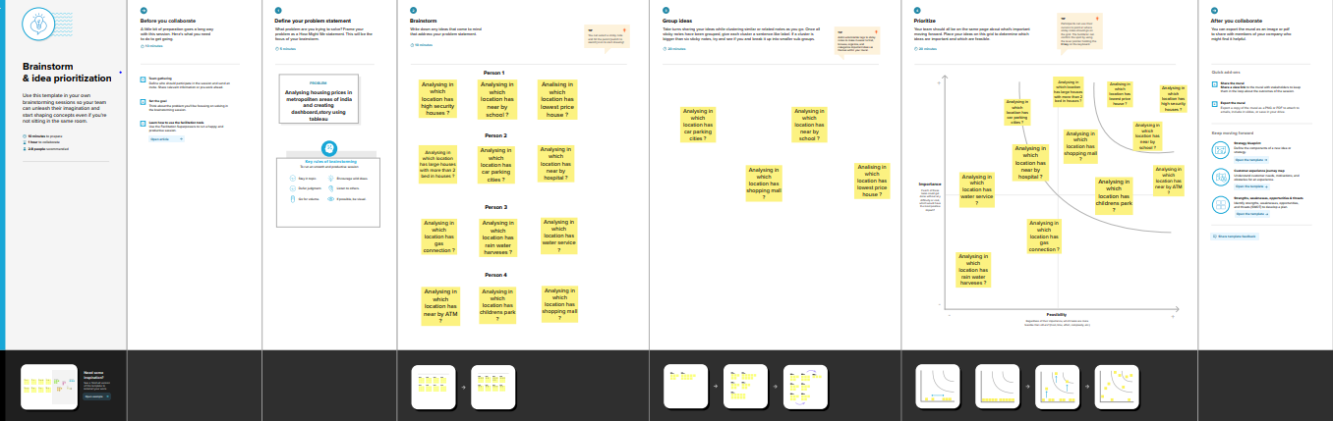  
3 RESULT

Activity 1: Analysing Location wise Count of Houses with nearby ATM

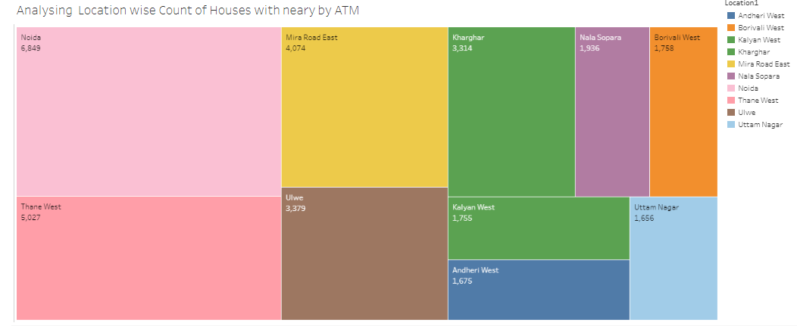

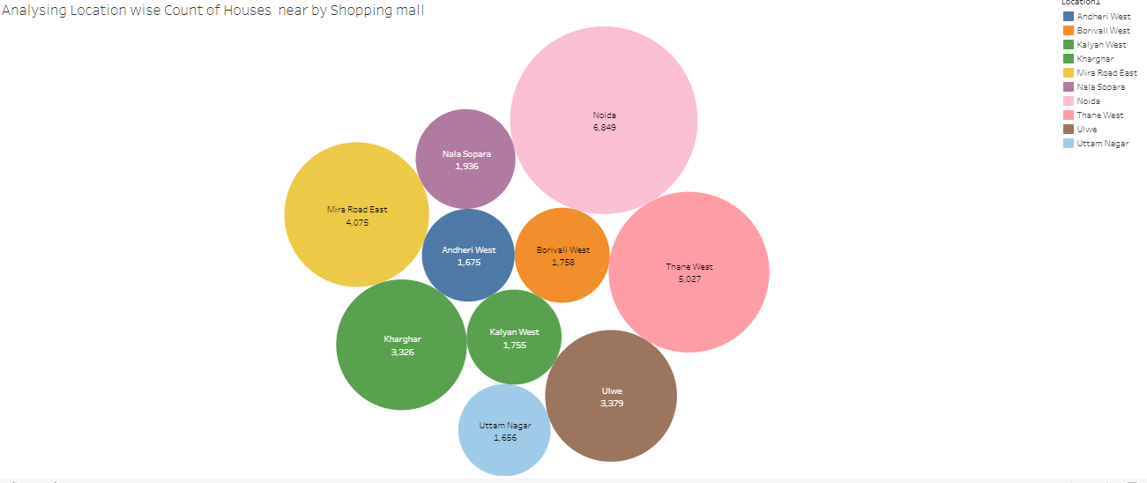

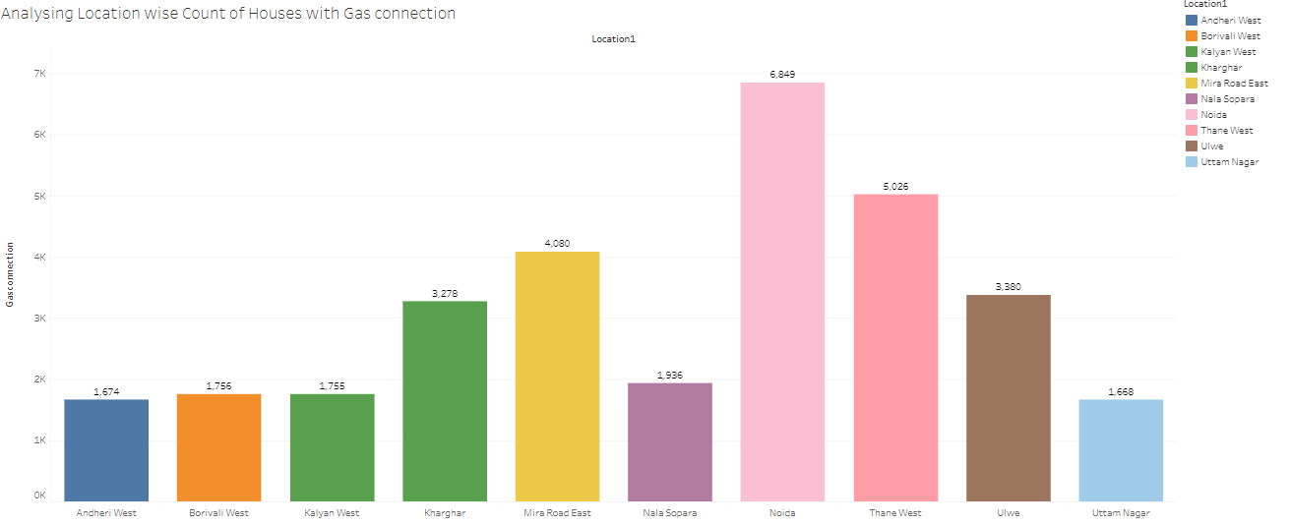

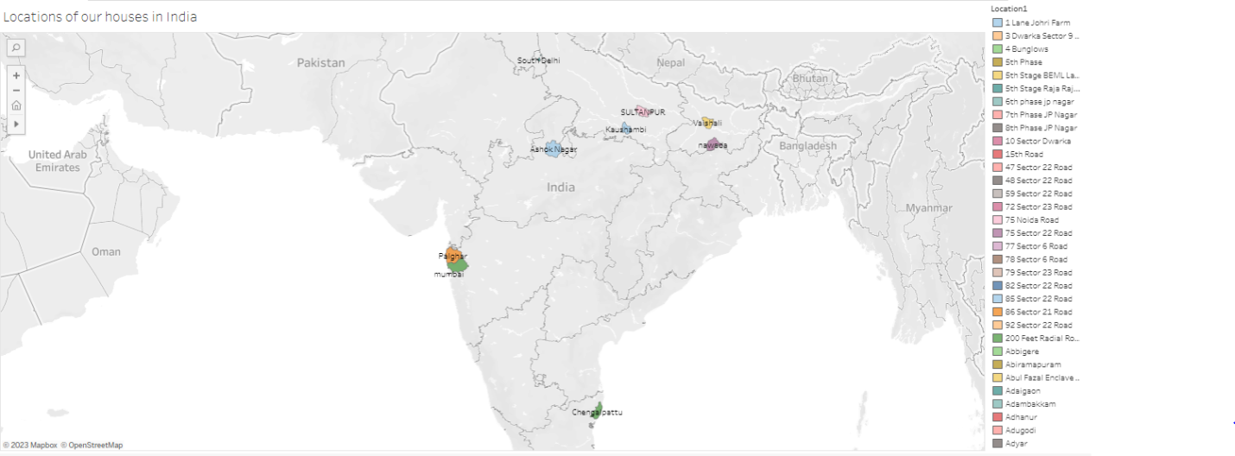

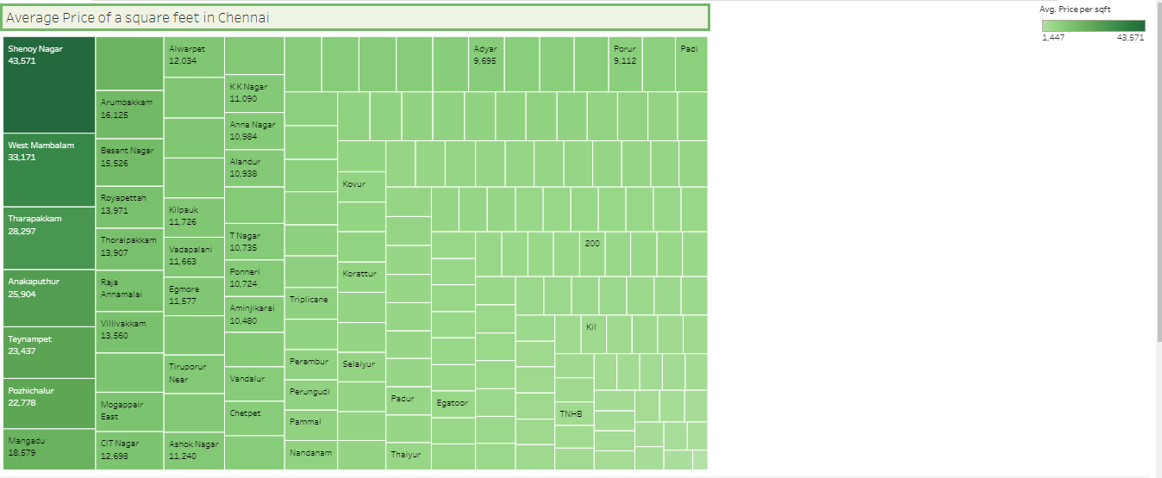

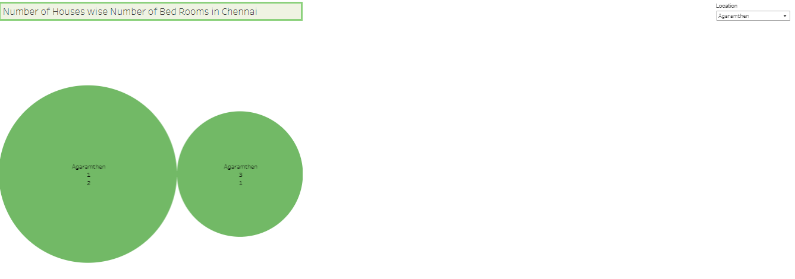

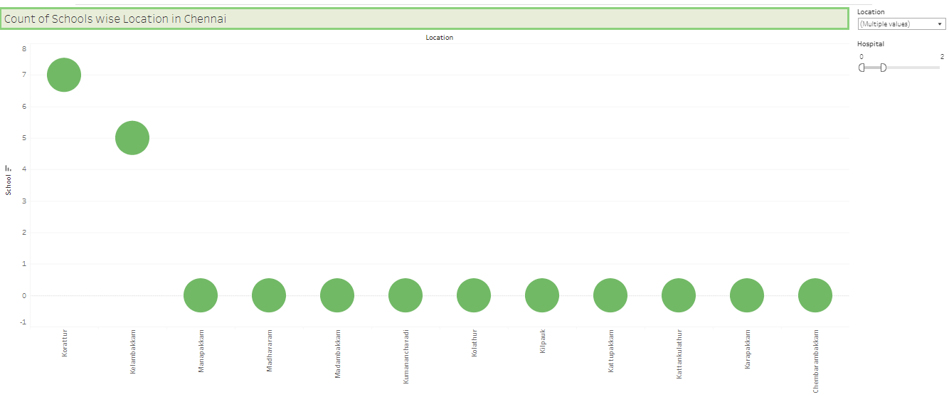

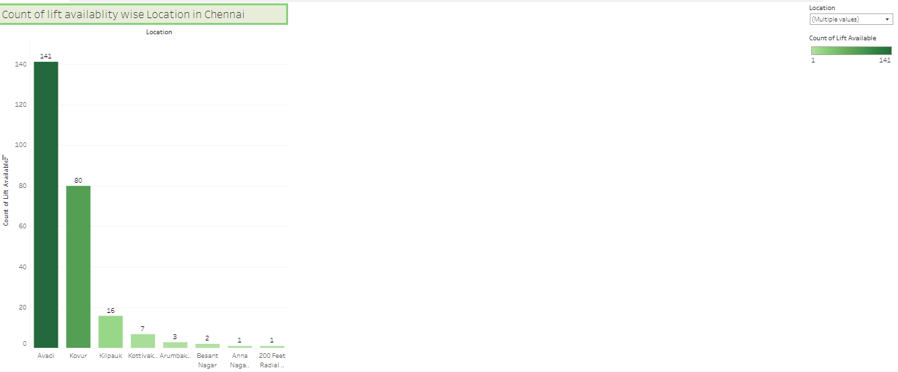

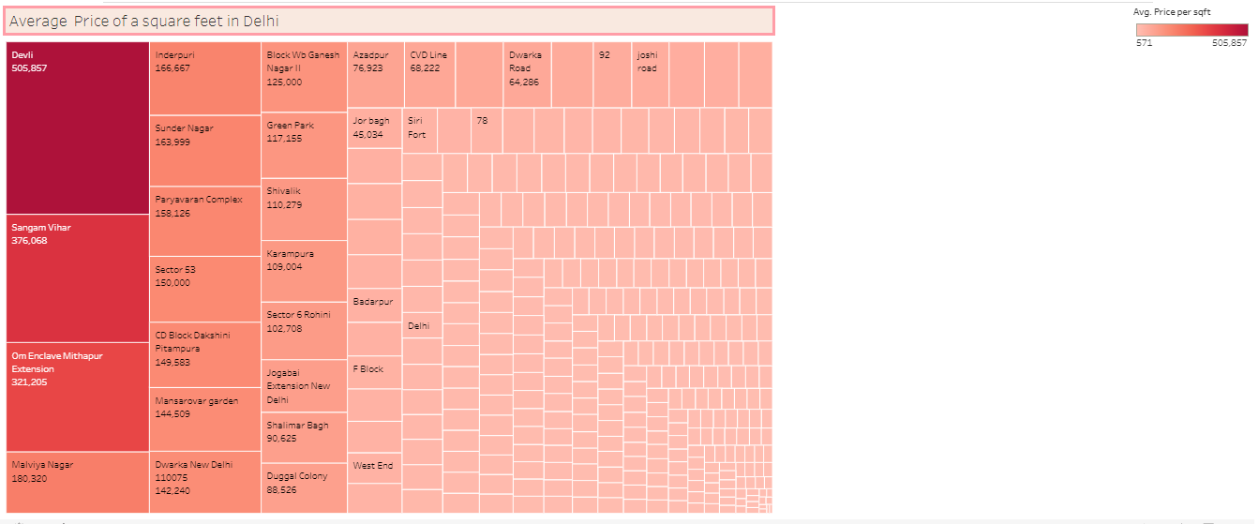

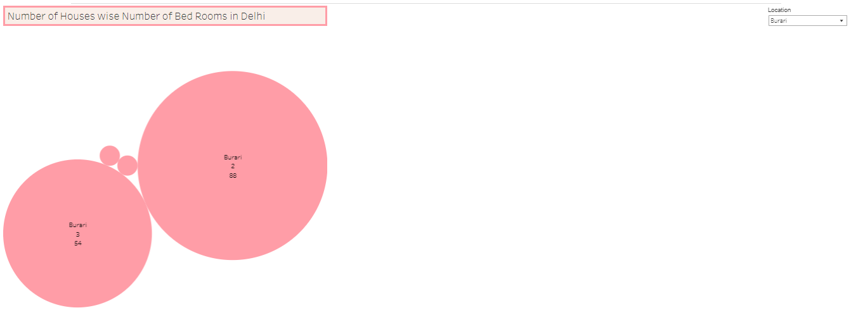

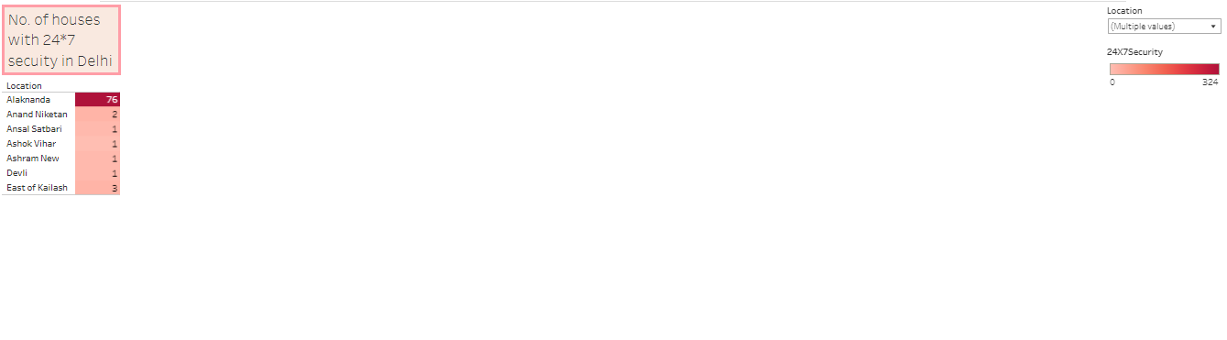

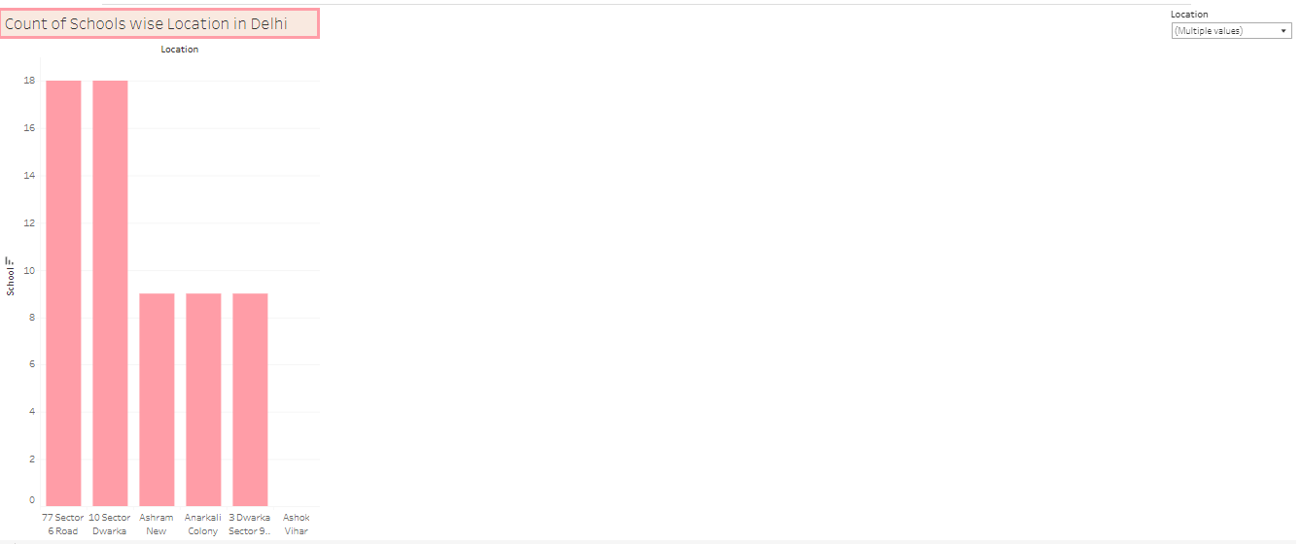

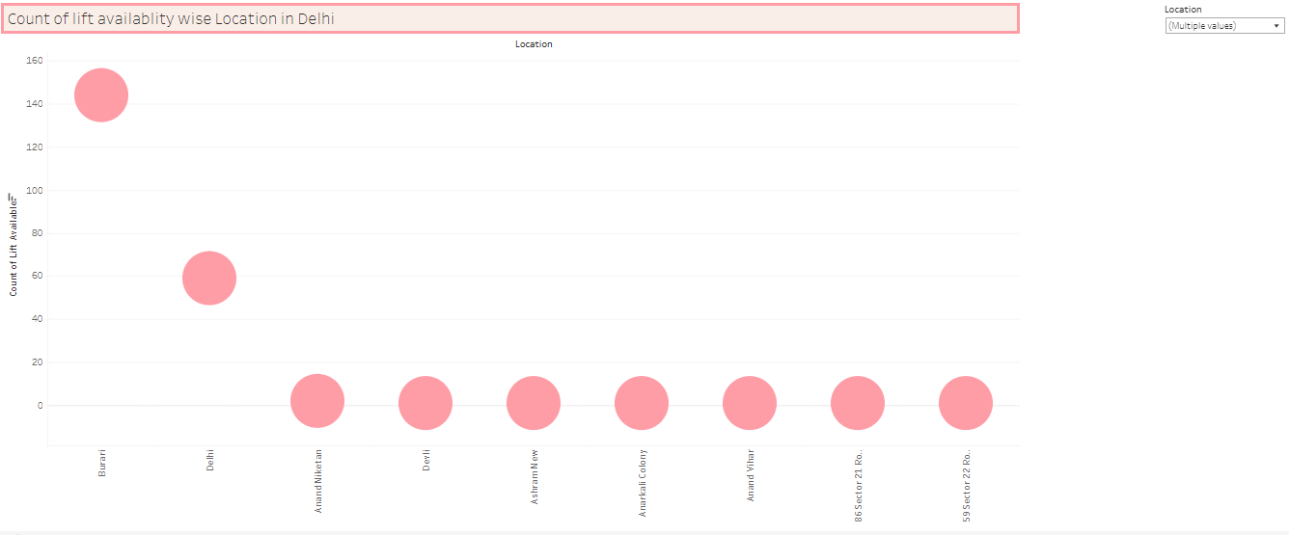

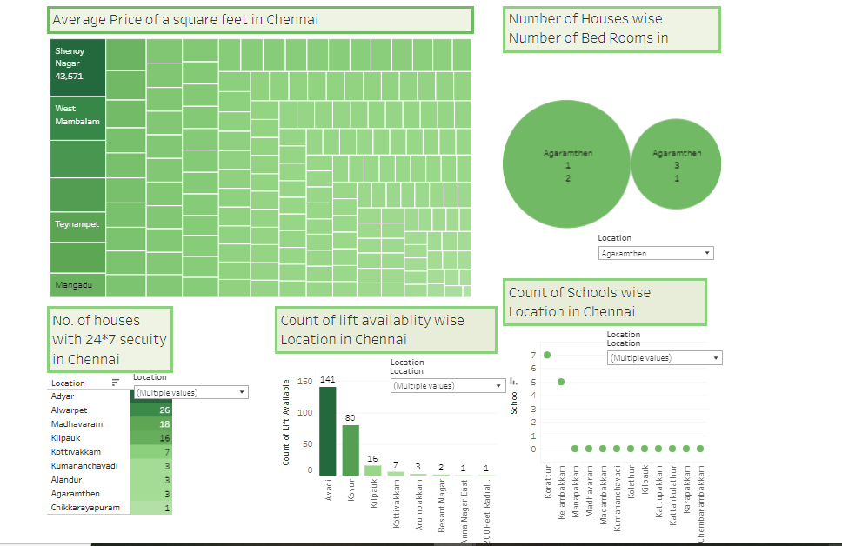

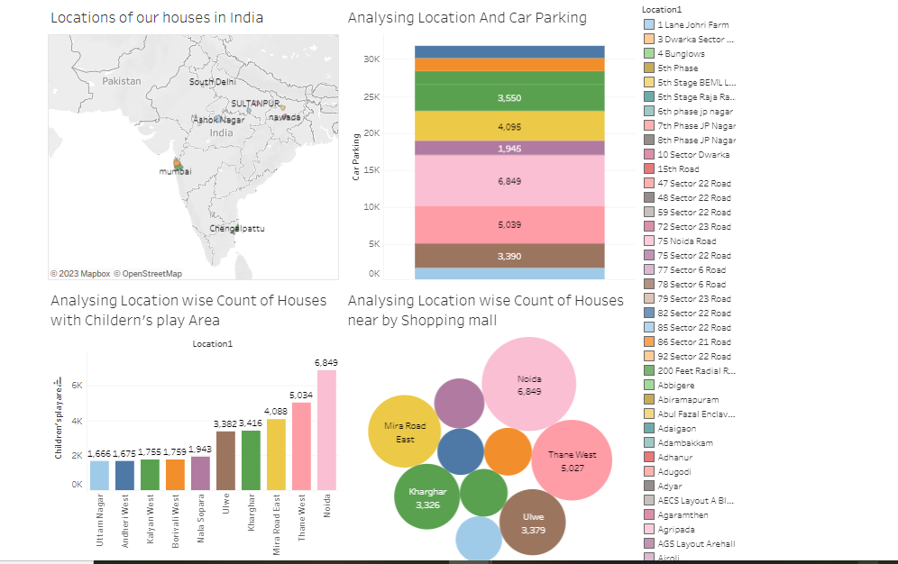

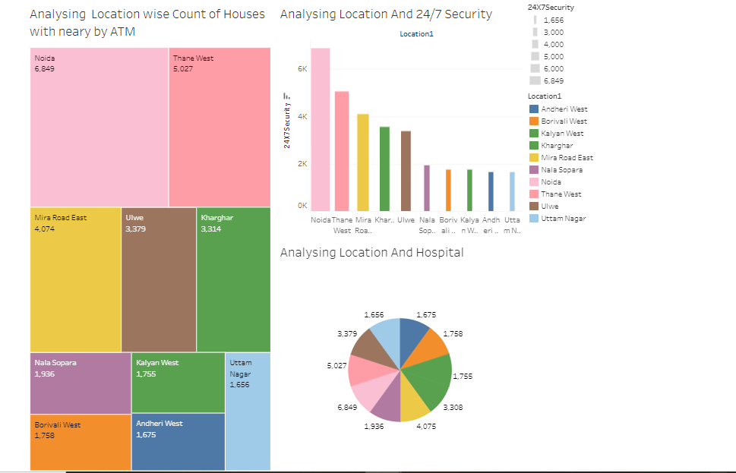

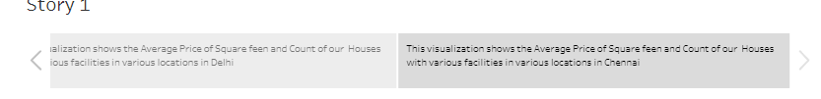

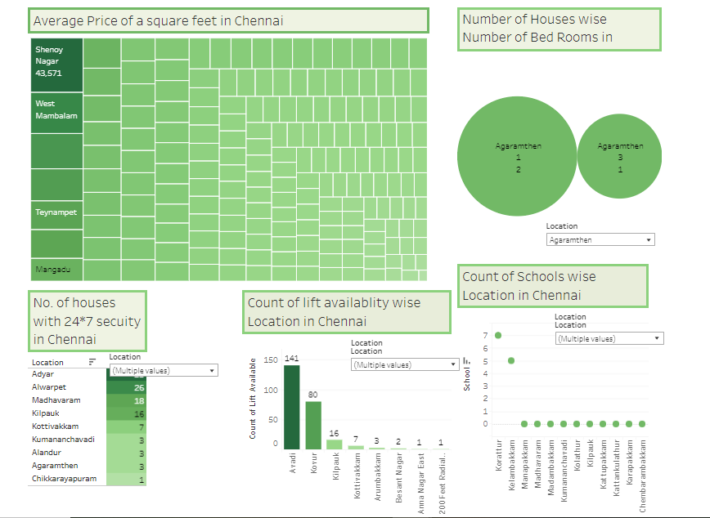

4 ADVANTAGES & DISADVANTAGES

The business requirements for house price prediction in a metropolitan city in India include developing an accurate prediction model that can estimate property prices. The model should identify the key features impacting house prices and provide insights to aid decision-making. It should be scalable to handle a large volume of data and incorporate real-time updates to reflect the latest market conditions. The solution should have a user-friendly interface, ensure transparency and explain the ability of predictions, prioritize data privacy and security, and define performance metrics for evaluation. Integration capability and cost-effectiveness are also important considerations to deliver a valuable and efficient solution.

5 APPLICATIONS

Houses with best facilities in India. By analysing the number of bed rooms and Services provided , may somebody with the dilemma to buy or not buy his/her own houses based on price and best facilities. Business Model/Impact: Can make this visualization application available for people, for more insights and ideas can ask for payment and also can give these insights to make the understand and help in the sense of buying house. Social Impact: Houses with best facilities in India. By analysing the number of bed rooms and Services provided , may somebody with the dilemma to buy or not buy his/her own houses based on price and best facilities. Business Model/Impact: Can make this visualization application available for people, for more insights and ideas can ask for payment and also can give these insights to make the understand and help in the sense of buying house.

6 CONCLUSION

In this project, we have analyzed thehousing prices in metropoliten areas of India and creating dashboard, story using tableau tool that assists users in navigating the competitive real estate market and maximizing their returns.

7 FUTURE SCOPE

In future, we can extend our analysis of houses with more facilities by collecting such data*.*